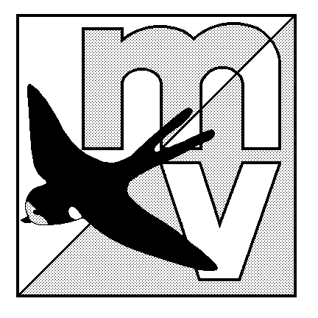 MOLE VALLEY ORIENTEERING CLUB
(Affiliated to the British Orienteering Federation)

DISTRICT (COLOUR CODED) EVENT

Balcombe – Near Crawley

Sunday 28th March 2004

Venue Balcombe is a combination of woodland with large rock features and open countryside.

Car Park Signposted from the B2036 in centre of Balcombe village at Grid ref. TQ307308.
Car Parking will be tight, please share cars if at all possible. Later arrivals may be directed to an overflow car park with half a mile walk to registration.

Map 1:10000 by Mike Elliot updated winter 2002; Contour Interval 5m.
Registration 09.30 - 11.30 Entry on the day only.

Starts 10.00 - 12.00 Courses close 14:30

Courses & White to Brown. Free string course. The event will be using SportIdent electronic
Punching punching (hire charge £1).

Fees Seniors £4.50. Juniors £2.00.

Facilities Squash, toilets, dogs welcome providing kept on a lead at all times.

Officials Organiser: Mark Rowe 020 8844 1370 mark.rowe@claritaseu.com
Planner: Chris McDonald Controller: Tim Denton (GO)

MV Web Site http://www.mvoc.org/

Safety Whistles recommended.

Competitors participate at this event at their own risk

